5 Hole Probe Data Acquisition Unit

By:

Luke Bergeron

May 2018

## Method of Operation:

The 5 Hole Probe Data Acquisition Unit is a device that acts as a data logger and controller board for a pitot probe with 5 tubes in a star-like pattern (see image below).

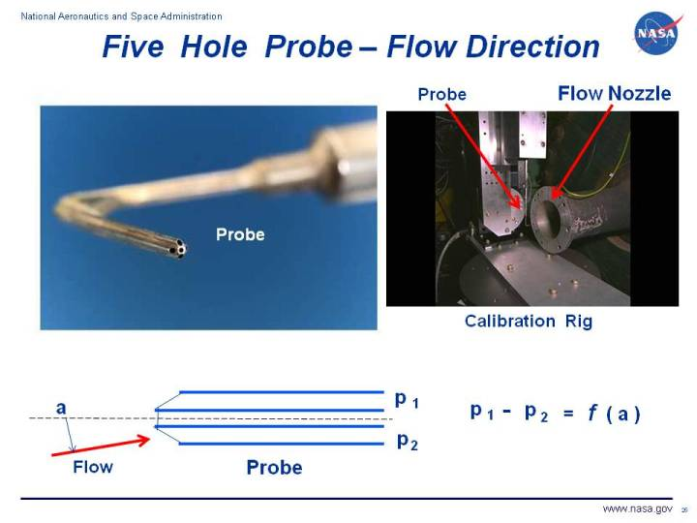

Example of a 5 Hole Probe (NASA).

The probe interfaces with the board via piezo pressure sensors and silicone tubing. Each tube (or port) is connected to a separate pressure sensor and converts air pressure to analog voltage. This analog voltage is directly proportional to the pressure and is linear when operated within the pressure ratings of the sensor. Since there are 5 ports, 5 pressure sensors are used (1410-P15D-12-11 from Merit Sensor). The analog output of each of the 5 pressure sensors are fed to separate 2 pole, passive, low pass filters each with a cutoff frequency of 240Hz. The output of each of the 5 filters are fed to a single Teensy 3.5 microcontroller and sampled. Each signal is currently set to be sampled at an average of 210Hz, but the microcontroller code can be adjusted to increase the sample rate to a maximum of 20KHz. After sampling, the raw data is saved to a text file an onboard Micro SD card. This data can then be plugged into a computer with MATLAB for data analysis.

In order to run flight tests, the pieces of software required are

* Datalogger_Teensy.ino with line 7 commented (for Teensy)
* Datalogger_MATLAB_Parser.m (for data analysis)

Note: there is a two position screw terminal on the board. One position is for ground and the other is for power. The input voltage range is 5-35V. Also, the power switch connected to the board must be in the “on” position.

In addition to data logging, the board is also used to help calibrate the probe. This is done by controlling a servo gimbal with the probe mounted on the top and placed in a wind tunnel. As the gimbal sweeps both angle of attack and side slip, all 5 port pressures are measured and sent to a lab PC via USB for data logging and analysis. There are two servo ports on the board that are used to control the gimbal during the calibration process. When plugging the servos in, the signal wire should on top and ground wire should be on the bottom (relatively speaking).

In order to run calibration tests, the pieces of software required are

* Datalogger_Teensy.ino with line 7 uncommented (for Teensy)
* Datalogger_MATLAB.m (for data acquisition)

Note: the software to analyze the wind tunnel pressure data is not yet developed.

Before wind tunnel testing, the servo gimbal is characterized by measuring (and recording) the true angles of attack and side slip for different commanded positions. The results of this characterization provide information on angle bias, reliability, and repeatability. In order to get these results, two IMUs are mounted to the probe gimbal (see image below).

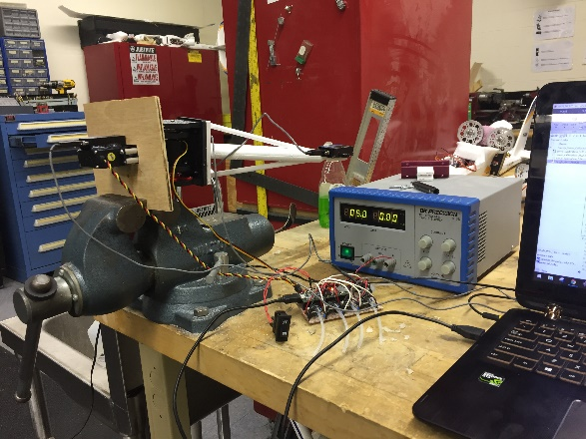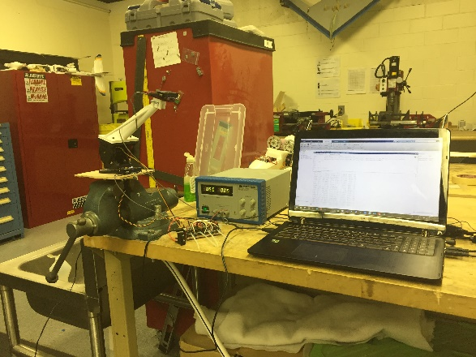

Gimbal Characterization of Angle of Attack (left) and Angle of Side Slip (right).

As can be seen in the two pictures, the placement of the IMUs differ when characterizing the angle of attack compared to side slip. Not only is the physical setup different, but there also is a software configuration change required when switching between the different tests.

In order to run calibration tests, the pieces of software required are

* Teensy_Servo_Calibration.ino with line 5 uncommented if characterizing angle of attack (for Teensy)
* Servo_Calibration_5HP.m with link 6 set to “testType = 'AOA';” if characterizing angle of attack and “testType = 'SSA';” if characterizing angle of side slip (for data acquisition)
* data_Processing_Script.m (for data analysis)

# Schematic